

Foundations of Programming
NAME- Ashutosh Kumar Dewangan
PRN-1262252582
DIV-11 CSE-AIDS

Lab Assignment No. : 03

PROBLEM STATEMENT:
Write a program in C to generate multiplication tables for a given number.
OBJECTIVES:
- To understand the use of looping statements in C.
- To generate multiplication tables using loops.
- To improve program logic and execution flow understanding.

THEORY:
Syntax for for loop example program
Syntax for while loop example program
Syntax for do while loop example program
ALGORITHM:

Type Program (Multiplication table)

PLATFORM:
Linux

INPUT:
Choice of operation and two numbers

OUTPUT:
Displays the result of the selected arithmetic operation

SAMPLE INPUT:
1
10 5

SAMPLE OUTPUT:
Addition = 15

CONCLUSION:
Thus, the menu driven program in C successfully performs basic arithmetic operations using switch–case statements.

FAQs:
- Which loop is best suited for generating multiplication tables?
- What is the role of loop initialization?
- Difference between for loop, while loop and do while loop?
- Can a do–while loop be used to generate multiplication tables? Explain.
- Why is the do–while loop called an exit-controlled loop?

Code:
#include<stdio.h>

int main() {
int num, i;

printf("Enter a number: ");
scanf("%d", &num);

printf("Multiplication Table of %d:\n", num);

for(i = 1; i <= 10; i++) {
printf("%d x %d = %d\n", num, i, num * i);
}

return 0;
}

CODE SCREENSHOT:

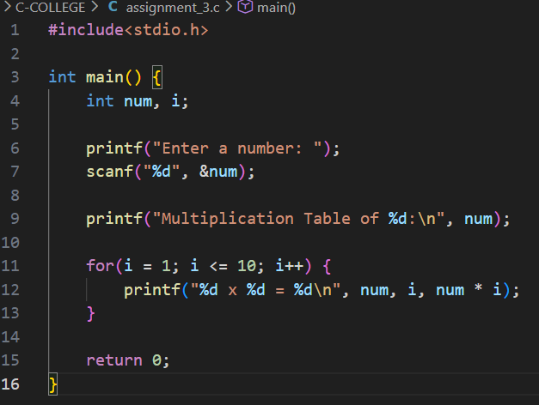

OUTPUT SCREENSHOT:
